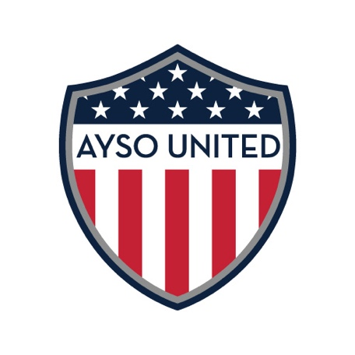
AYSO UNITED’S VISION, MISSION AND PLAN

AYSO's Vision is to provide world class youth soccer programs that enrich children's lives.
AYSO United’s Mission is to develop and deliver quality youth soccer programs which promote a fun, family environment based on AYSO's Philosophies, especially; Everyone Plays, Player Development, Positive Coaching and Good Sportsmanship.
AYSO United Hill Country’s Plan is to develop exceptional soccer players by focusing on the following principles:
- Player Development and Team Development over winning – yes we want to win, but we will not sacrifice the development of the player and the team for a win. Some games may focus on possession, passing, playing out from the back or other tactical plays instead of focusing on the win. Every player on the team will play, even if he is not the “best.”
- Ball Control over random kicks – Big kicks are fun and give a good show! They are also, at best, a 50-50 shot at winning the ball and making a good play or shot on goal. We will develop ball control and passing.
- Creativity over static play – While we will teach the basic formations of soccer, we will also teach movement on and off the ball, creative ball control, using the field as canvass.
- Positivity – We will strive to be positive in coaching, in winning, and in losing. We expect the same behavior from players and parents.

AYSO United Hill Country’s goal is to enrich children’s lives using the game of soccer. We want to establish a dynamic program where the children learn to play soccer to the highest extent of their abilities and play with exceptional sportsmanship. We hope that you envision yourself and your child growing with Fredericksburg’s very own club league soccer team!

